XMLTV2MXF Setup Guide V0.5

Step 1: Setup Tuners

These steps are for a single, DVB-T freeview HD tuner. If you are using a DVB-S or analogue tuner, stick to Vista. Multiple tuners should be similar.

Launch Media Center

- Menu: “Tasks”..”Settings”..”TV”..”TV Signal”..”Set up TV Signal”
- At this point you may get a warning box: "Changing these settings will affect....". Click: “OK”
- “Region: New Zealand” should be set, if not select it. Click: “Next”
- “Postal Code: “, type in your NZ postal code. Cick “Next”
- “Program Guide Terms of Service”, select “I agree”. Click “Next”
- “Downloading TV Setup Data”. Just wait. You will eventually get an error “Downloadable Guide Not Available”. We are going to fix this – Click “Next”
- “TV Signal Type:”, select “Digital Antenna (DVB-T)”. Click “Next”
- “TV Setup Finished”. Select “No” for “Do you want to set up another TV signal?”. Click “Next”
- “TV Signal Confirmation”. Click “Next”
- “TV Channel Scan”. Just wait, we should find 10+ channels in this process. Click “Next”
- “TV Signal Setup Finished”. Click “Finish”

Step 2: Setup XMLTV2MXF

- Decompress the contents of the supplied archive to c:\Guide
- Browse to this in explorer, you should have something like the following: (NB, later versions also have “WPFToolkit.dll, log4net.dll” and may have “XMLTV2MXF.log” also.)
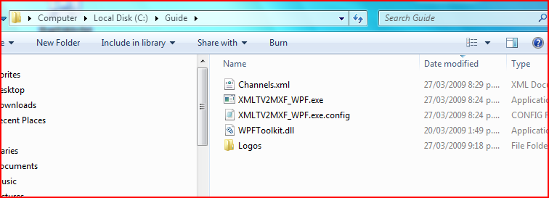
- Now copy the files: ChannelInfo.xml, xmlTVNZ.exe, xmlTVNZ.exe.config, xmlTVNZMarkers.xml from your xmlTVNZ v3+ installation folder into c:\Guide
- You should now have:
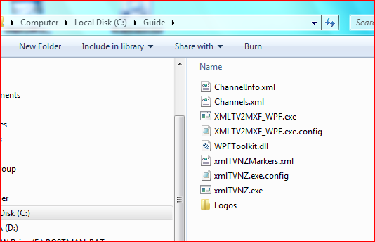
- Double-Click on “XMLTV2MXF_WPF.exe”, you should see 2 windows appear, a console window and a form (just wait a second, this can take a couple to appear)
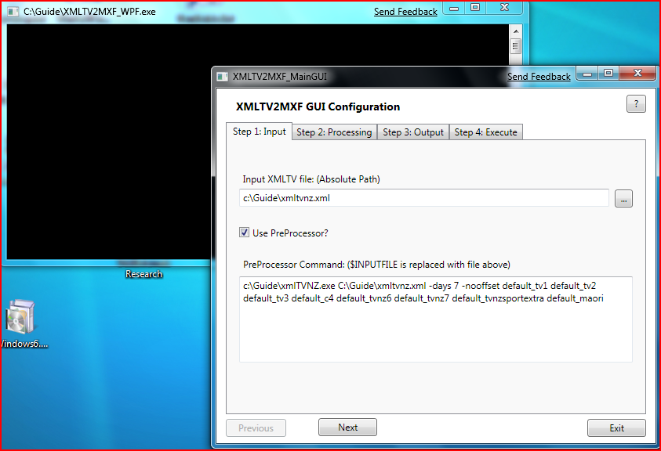
- Use the first 3 tabs to configure the tool: the defaults should work. You can change tabs by clicking on their titles or using the "Prev” / “Next" buttons.
- Tab: “Step 1: Input”. Configure the input to the application.
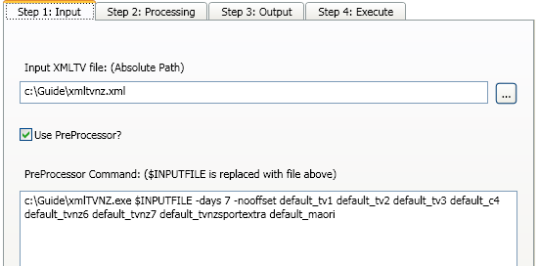
  - “Input XMLTV file:” textbox. This is where you type the path/name of the file that will be outputted by xmltvnz. You can use the "..." button to browse for this. This MUST be an absolute path (e.g. start in "c:\" or "d:\" or similar).
  - “Use PreProcessor?” checkbox. This tells the app whether to run an external application before converting from the input file to output. You can (and probably should) use this to run XMLTVNZ. The application that is run is entered in the "PreProcessor Command:" textbox.
  - “PreProcessor Command:” textbox. This is where you type the command line of the application that generates the xmltv file. The xmltvnz example entered should work fine. Notice that we used the string "$INPUTFILE" where we would normaly type the xmltvnz output file name (which becomes the input for this application)
- Tab: “Step 2: Processing”. This describes how the processing will be performed.
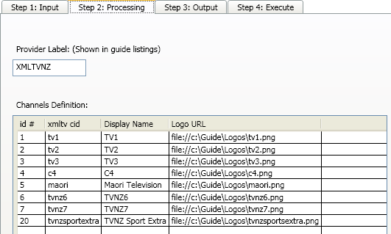
  - “Provider Label:” textbox. This string is appended to the end of the channel name when we get to attaching listings to channels in Media Center. It must have no spaces. It doesn't matter what this is really, although it can be handy to change it so that you know you are attaching a fresh set of guide listings.
  - “Channels Definition:” grid. This grid is where you tell the application what channels to look for in the xmltv file. It is a good idea to not have spaces in any of these fields except "Display Name"
    - “id” column: is a unique number for the channel. I think it helps if this matches the channel number in media center.
    - "xmltv cid" column: is the string inside the xmltv file that is used to represent the channel. I've listed a few, but if you want more look in the "ChannelInfo.xml" file we copied across from your xmltvnz directory. These strings are the <channelID> attribute.
    - "Display Name" column: this is what is shown in Media Center. You can use spaces.
    - "Logo URL" column: this is a url to a .png file to show up in the guide. I have provided sample ones of these, you will need to get your own for any other channels. You cannot have this blank, but putting in a non-existent file wont break anything.
- Tab “Step 3: Output”. This is where you configure the output of the processing.
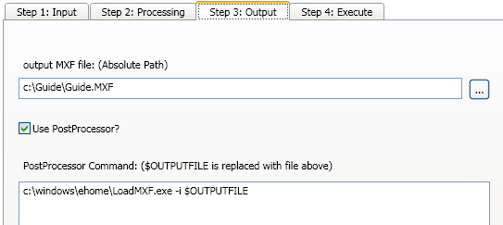
  - “output MXF file:” textbox. This is the path/file that we will write out the mxf file for loading into Media Center. It must be an absolute path. You can use the "..." button to browse if you want.
  - “Use PostProcessor?” checkbox. This tells the app whether to run an external application after converting from the input file to output. You can (and probably should) use this to run LoadMXF.exe. The application that is run is entered in the "PostProcessor Command:" textbox.
  - “PostProcessor Command:” textbox. This is where you type the command line of the application that consumes the mxf file. The LoadMXF.exe example entered should work fine. Notice that we used the string "$OUTPUTFILE" where we would normaly type the LoadMXF input file name (which is the output from this application)

- Tab “Step 4: Execute”. This allows you to run the application from within the GUI.
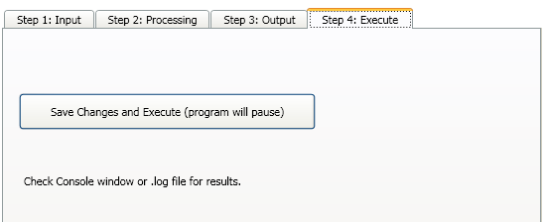

  - “Save Changes and Execute” button. This will start the conversion process, running the pre/post conversion applications if configured. Because the application will normally be run from the command line, all output information will sent to the console window (and to the log file). Also, after pressing this button, the application may appear to stall:
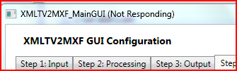
Just be patient, the application is actually running.

Finish up by clicking the close (red X) button on either of the two windows (console or GUI) or the "Exit" button on the GUI.
Answer "Yes" to the prompt to save your settings.

Step 3: Configure MCE
- Open Media Center
- Tasks..settings..TV..Guide..Edit Channels
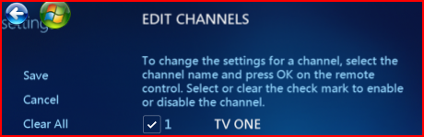
- If you are lucky, some of the channels will have picked up the listings. do the process below for each anyway, to make sure we have disabled the inband programming.

For each channel listed on the right hand side:
- Click on the channel you want to edit. eg "TV ONE"
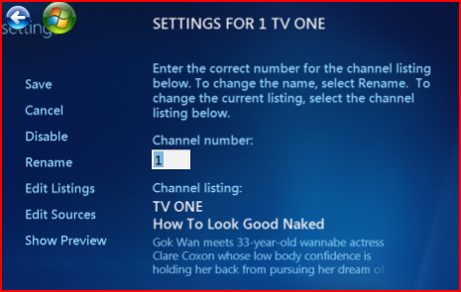
(this may already have a sample listing from inband)
- Click "Edit Listings"

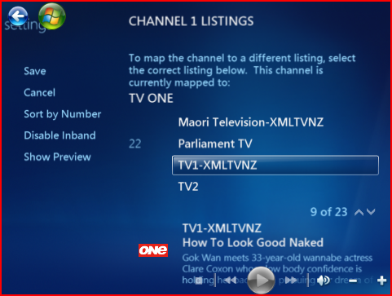
- Click "Disable Inband" it should change to "Enable Inband". This stops our xmltvnz listings being bashed by crappy broadcast ones. This may not be available on all channels
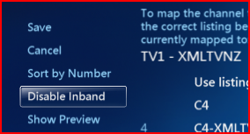
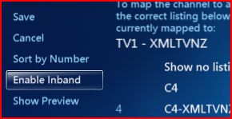
- Browse the list on the right-hand side. There should be an entry like "Tv1-XMLTVNZ" (The "TV1" is the channel cid, XMLTVNZ bit is the "provider string" from XMLTV2MXF). Select It
- We are now back at the SETTINGS FOR 1 TV ONE page
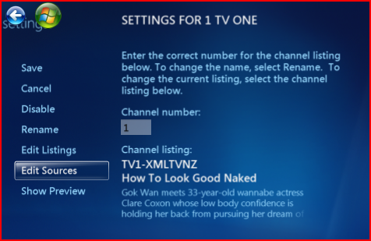
- Click "Save"
- Click "Save" again.
- We are now back at the "EDIT CHANNELS" page.
- repeat for other channels. deselect the check box next to a channel for it not to be displayed in the guide.
- Click "Save". This should take you back to the "GUIDE" menu.
- Go back to the main Media Center menu.
- TV..Guide
- The guide should look something like this - yay!
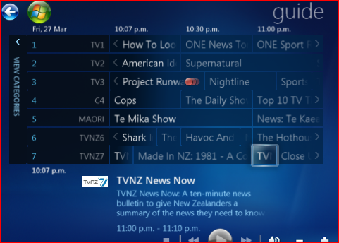

Step 4: Automate the Process

- As well as the GUI mode that we have seen, there is a mode that is better for scripting or running periodically, for example:
- press "Windows-R" and type "cmd" and press enter.
- type "CD \Guide" and press enter.
- type "XMLTV2MXF_WPF.exe" and press enter. You should see the window that you saw before. Close the GUI form.
- In the console window type this instead "XMLTV2MXF_WPF.exe /batch:true". You will now not see the GUI form and it should start processing with the settings you saved last time.
- To schedule this to run every day at 1am, type the following (replace “mceuser” and “mcepass” with the username/password you use for Media Center):
schtasks /create /tn GuideXMLTV /tr "C:\Guide\XMLTV2MXF_WPF.exe /batch:true" /sc DAILY /st 01:00 /ru:mceuser /rp:mcepass
- Press enter. You should see a line like:
SUCCESS: The scheduled task "GuideXMLTV" has successfully been created.
- This should now run every night at

